- Install git.

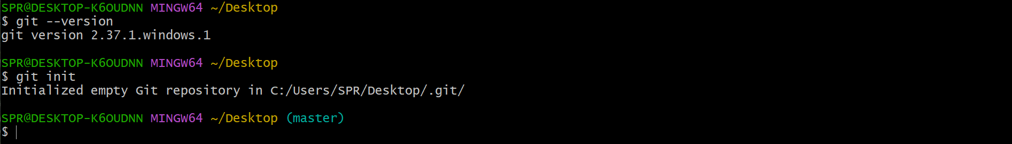

- Create a repo in github with README.md and .ignore file.

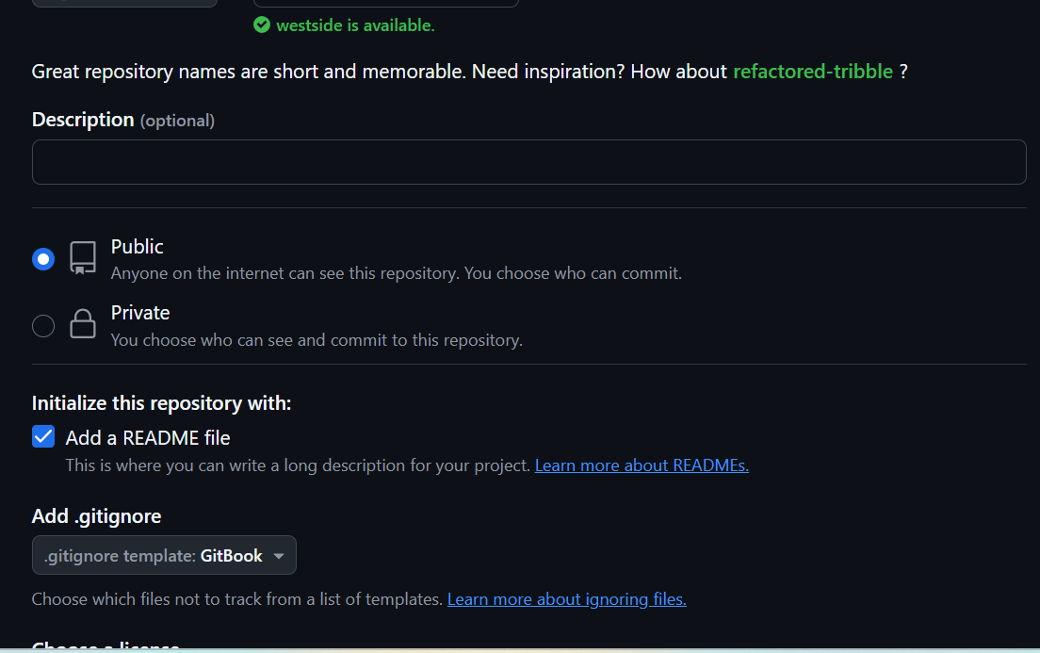

- Clone the created repo to local.
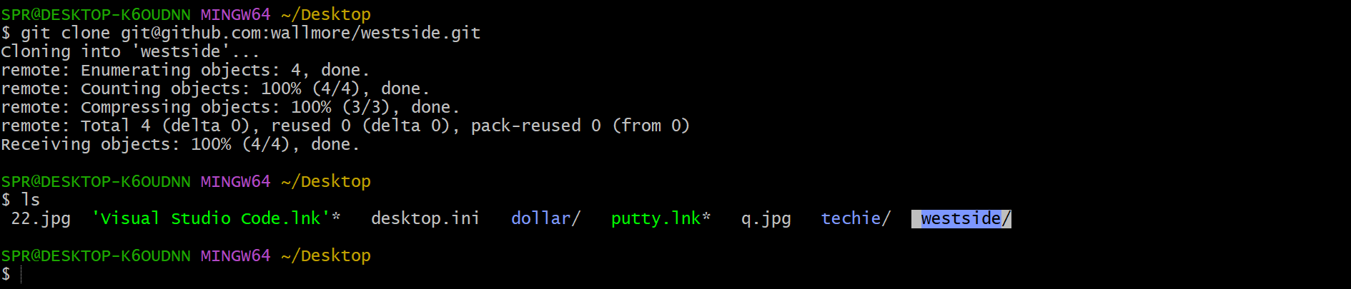

- Create two files in local repo.

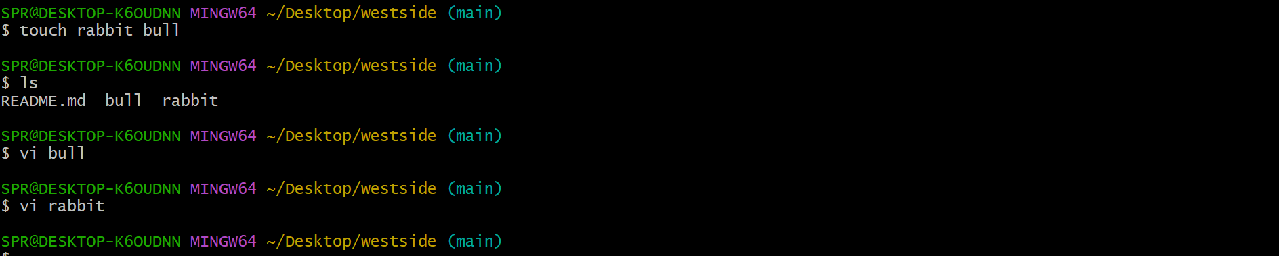

- Commit two files and push to central Repository.

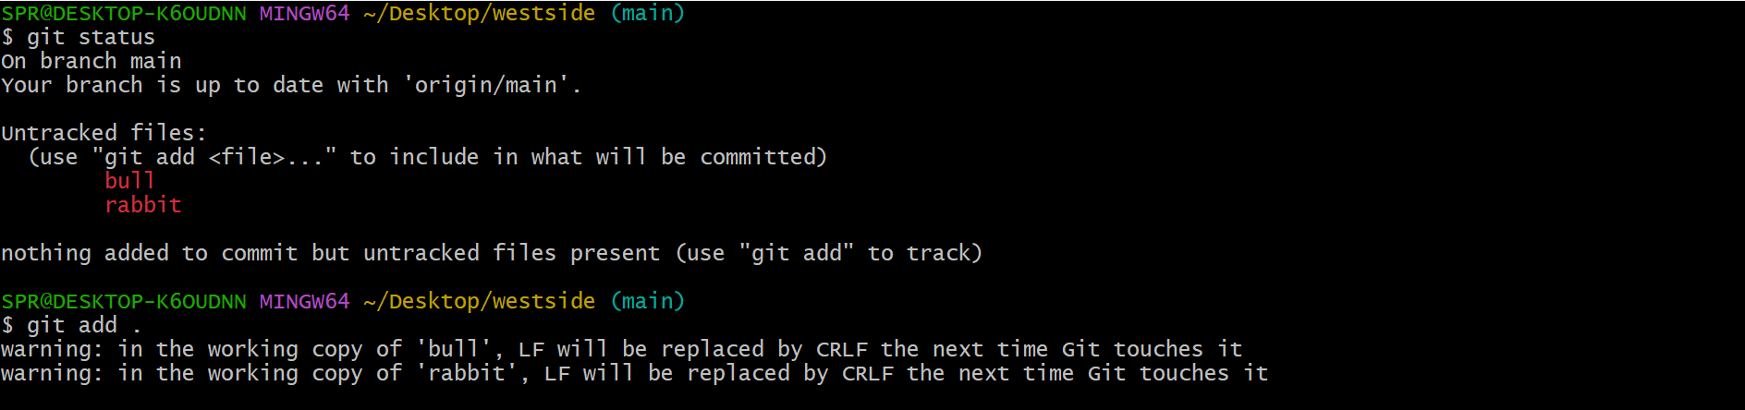
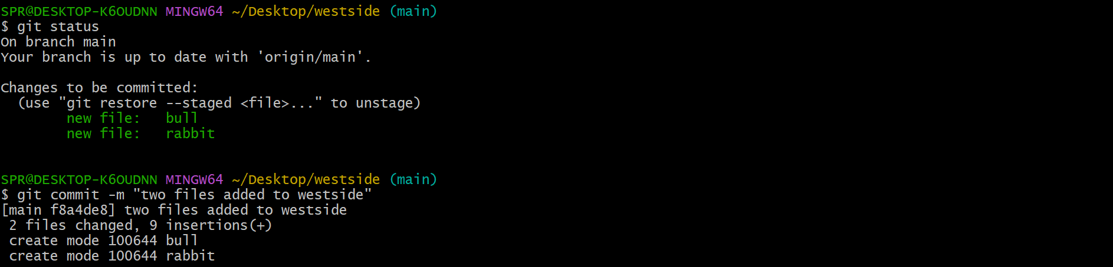
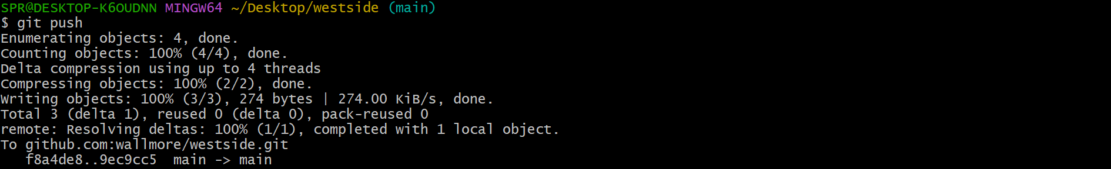

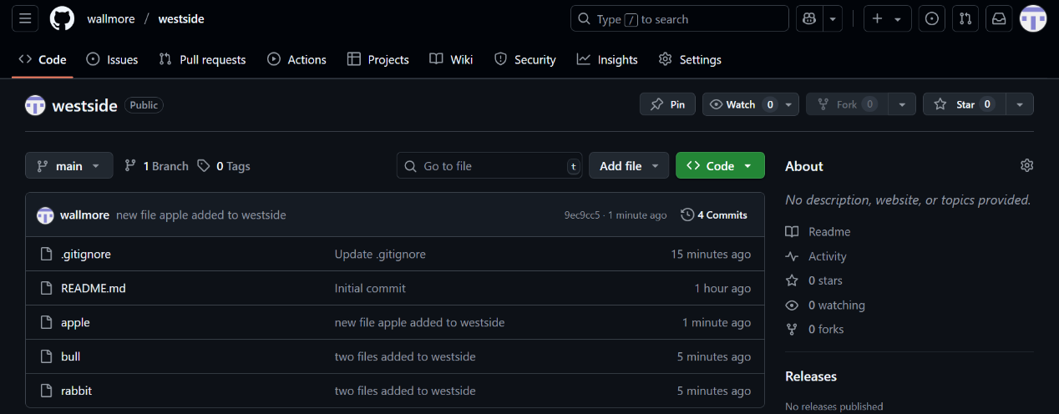

- Create a branch in local and create a sample file and push to central.

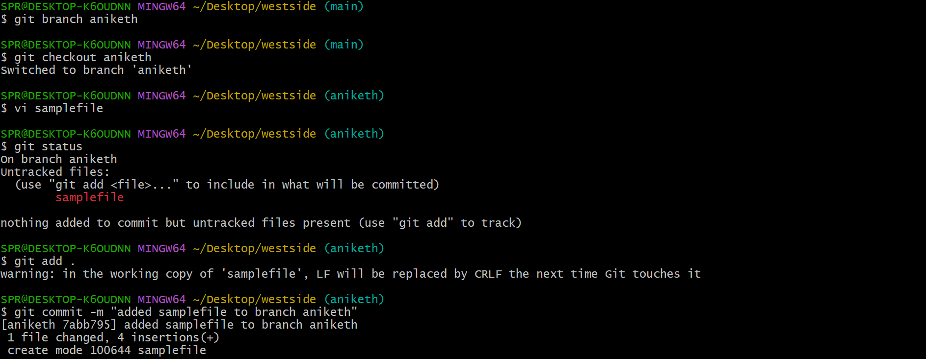
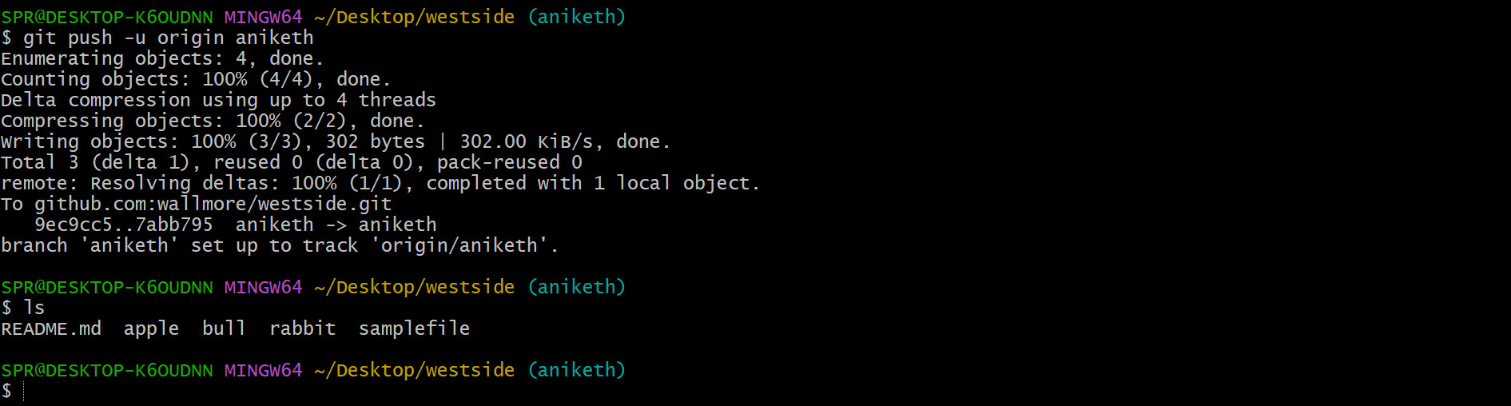

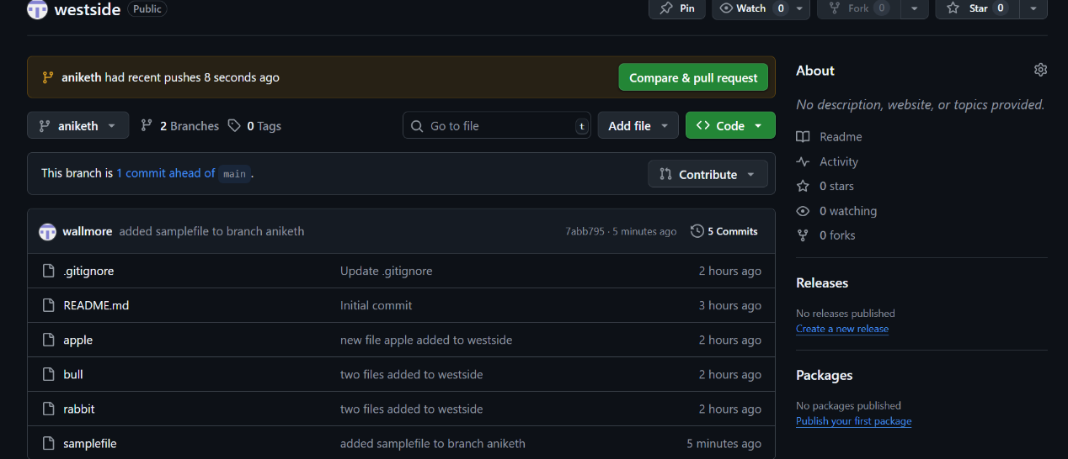

- Create a branch in github and clone that to local.
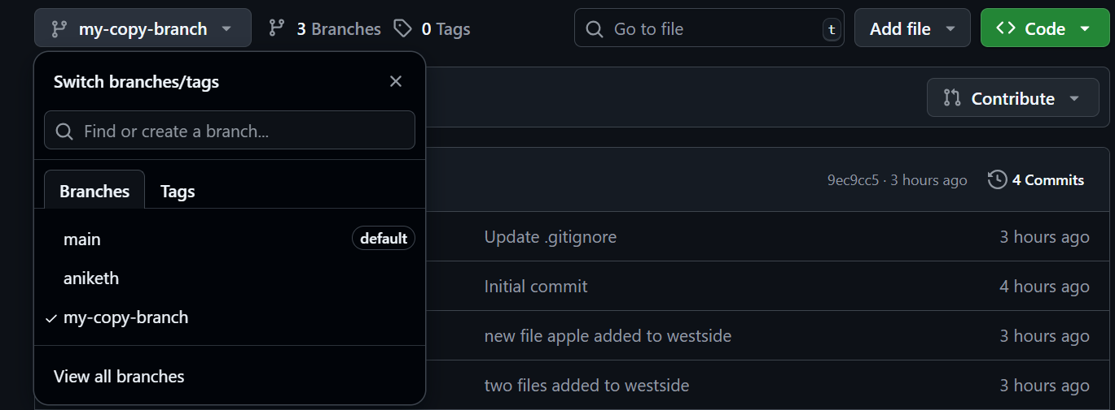

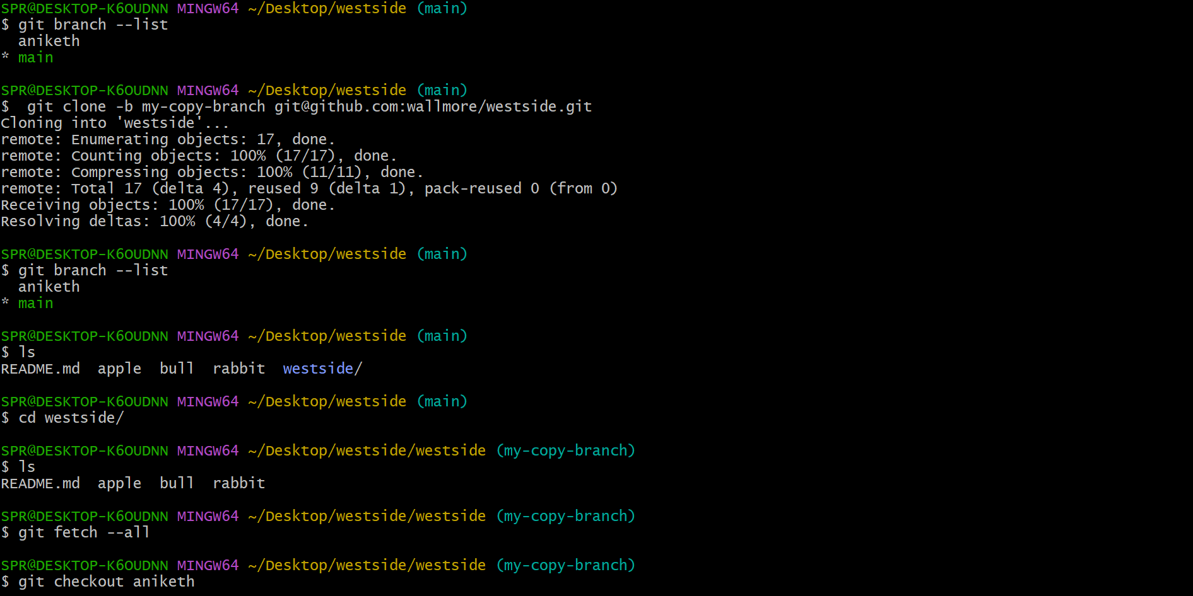

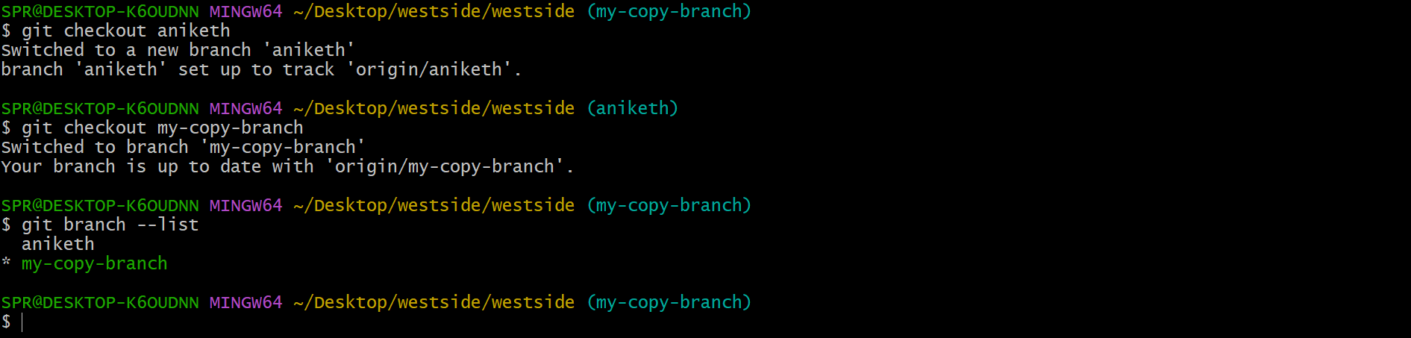

- Merge the created branch with master in git local.

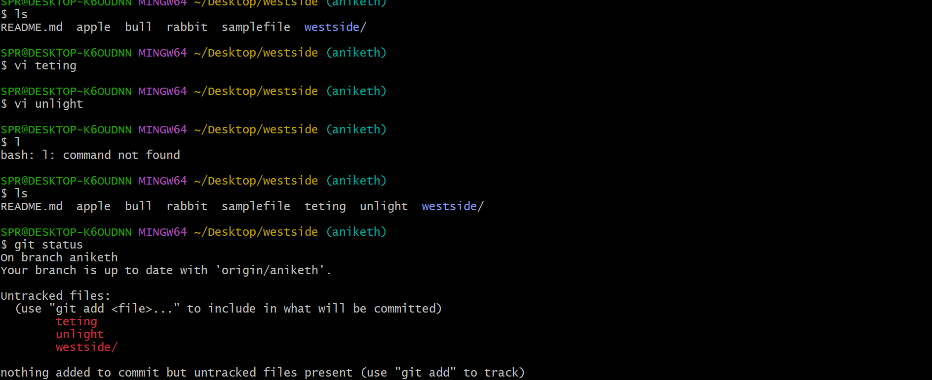

- Merge the created branch with master in github by sending a pull request.
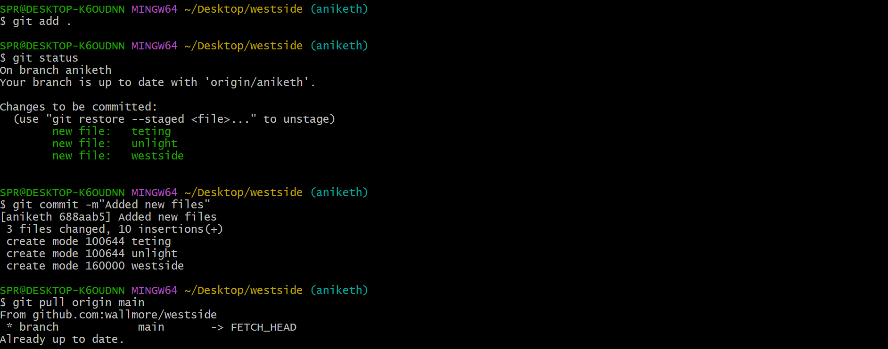

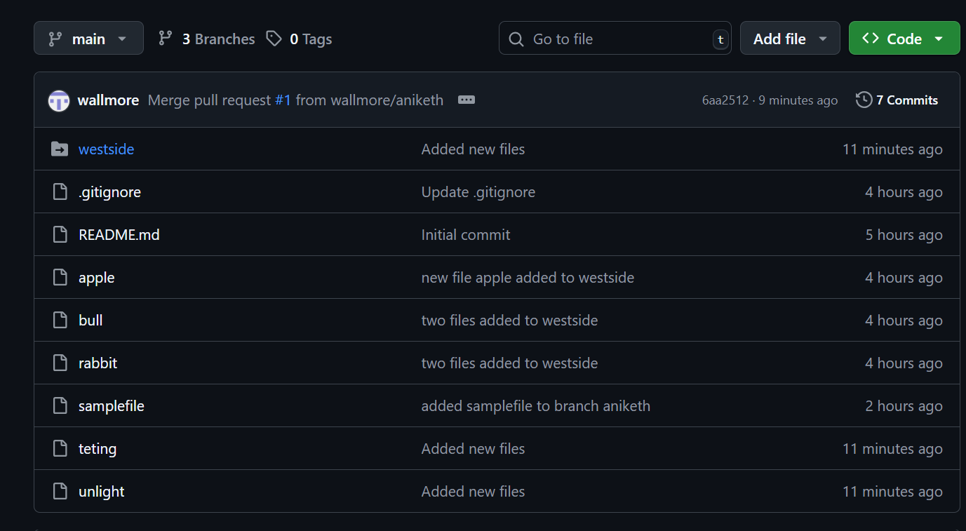

- create a file in local and send that to branch in github.

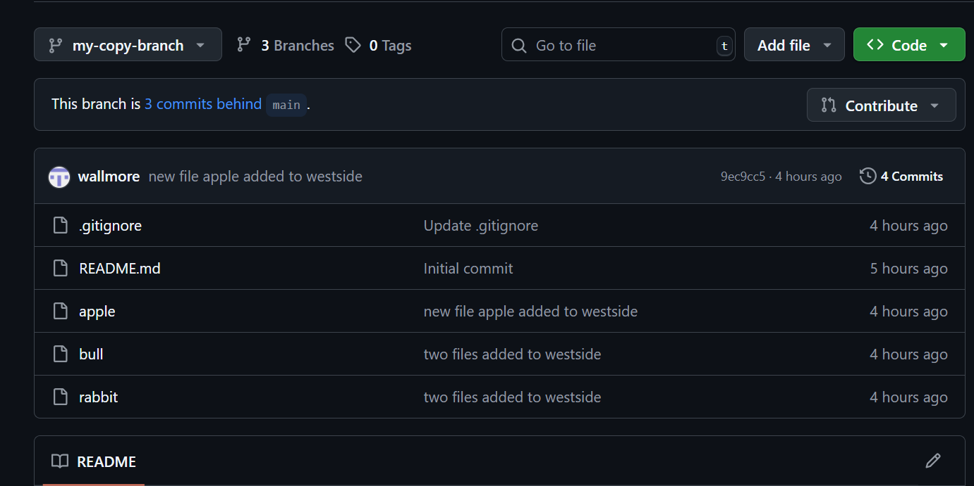

- generate a ssh-keygen and configure into github.
